Project Title | E-Commerce Order, Delivery & Customer  Performance Analysis
Skills take away From This Project | SQL (joins, aggregations, subqueries), Data Cleaning & Transformation, KPI Development, Time-Series Analysis, Data Visualization (Power BI / Tableau / Excel), Business Insight Generation, Dashboard Storytelling, Customer & Seller Performance Analysis
Domain | E-Commerce Analytics / Supply Chain Analytics  / Customer Intelligence
1. PROJECT OVERVIEW
This project focuses on analyzing a multi-table e-commerce dataset to evaluate order lifecycle performance, delivery efficiency, customer behavior, and seller performance.
The analysis simulates a real-world scenario where an e-commerce organization aims to optimize operations, improve delivery timelines, and enhance customer experience using data-driven decision-making.
Project Goal
To apply Business Analytics concepts and tools to analyze transactional data and identify operational inefficiencies, customer behavior patterns, and performance gaps.
Expected Outcome
- Identification of inefficiencies in order processing and delivery
- Insights into customer satisfaction and retention
- Seller and product performance benchmarking
- Development of interactive dashboards for decision-making
- Actionable business recommendations
2. BUSINESS PROBLEM DEFINITION
E-commerce platforms operate in a dynamic environment involving customers, sellers, logistics, and payments.
Operational inefficiencies such as delivery delays, inconsistent seller performance, and poor customer satisfaction can significantly impact business performance.
Business Objectives
- Improve delivery performance and reduce delays
- Enhance customer satisfaction and retention
- Identify high-performing sellers and product categories
- Optimize operational efficiency
Key Business Questions
- Where are delays occurring in the order lifecycle?
- Which sellers and categories drive performance?
- What factors influence customer satisfaction?
- How can customer retention be improved?
Stakeholders
- Operations Team
- Logistics Team
- Seller Management Team
- Category/Product Managers
- Executive Leadership
3. DATASET
The dataset is provided as part of project resources and contains multiple relational tables representing different aspects of e-commerce operations.
This dataset has information about the customer and its location. Use it to identify unique customers in the orders dataset and to find the orders delivery location.
At our system each order is assigned to a unique customer_id. This means that the same customer will get different ids for different orders. The purpose of having a customer_unique_id on the dataset is to allow you to identify customers that made repurchases at the store. Otherwise you would find that each order had a different customer associated with.
Please refer to the data schema provided in next section
1. Orders Table

Purpose:
Contains the order lifecycle information from purchase to delivery.

Key Columns:
- order_id → Unique identifier for each order
- customer_id → Links order to customer
- order_status → Status (delivered, shipped, cancelled, etc.)
- order_purchase_timestamp → Date & time when order was placed
- order_approved_at → When payment was approved
- order_delivered_carrier_date → When order was handed to carrier
- order_delivered_customer_date → Actual delivery date
- order_estimated_delivery_date → Expected delivery date

This is the central table (fact table)

2. Order Items Table

Purpose:
Contains product-level details for each order

Key Columns:
- order_id → Links to orders
- order_item_id → Item number within order
- product_id → Links to products
- seller_id → Links to seller
- price → Product price
- freight_value → Shipping cost

3. Customers Table

Purpose:
Contains customer-level information

Key Columns:
- customer_id → Unique customer identifier
- customer_unique_id → Identifies repeat customers
- customer_city → Customer city
- customer_state → Customer state

4. Products Table

Purpose:
Contains product details and categories

Key Columns:
- product_id → Unique product identifier
- product_category_name → Product category
- product_weight_g → Weight
- product_length_cm → Dimensions
- product_height_cm
- product_width_cm
5. Sellers Table

Purpose:
Contains seller information

Key Columns:
- seller_id → Unique seller identifier
- seller_city → Seller location
- seller_state → Seller state

6. Payments Table

Purpose:
Contains payment transaction details

Key Columns:
- order_id → Links to orders
- payment_type → Credit card, boleto, etc.
- payment_installments → Number of installments
- payment_value → Total payment amount

7. Reviews Table

Purpose:
Contains customer feedback and satisfaction data

Key Columns:
- review_id → Unique review
- order_id → Links to orders
- review_score → Rating (1–5)
- review_creation_date → Date of review

8. Geolocation Table

Purpose:
Provides geographic mapping data
Key Columns:
- geolocation_zip_code_prefix
- geolocation_city
- geolocation_state

🔗 DATA RELATIONSHIPS (VERY IMPORTANT)

Students must understand how tables are connected:

- Orders ↔ Customers → customer_id
- Orders ↔ Order Items → order_id
- Order Items ↔ Products → product_id
- Order Items ↔ Sellers → seller_id
- Orders ↔ Payments → order_id
- Orders ↔ Reviews → order_id
Students are required to integrate these datasets using SQL joins.
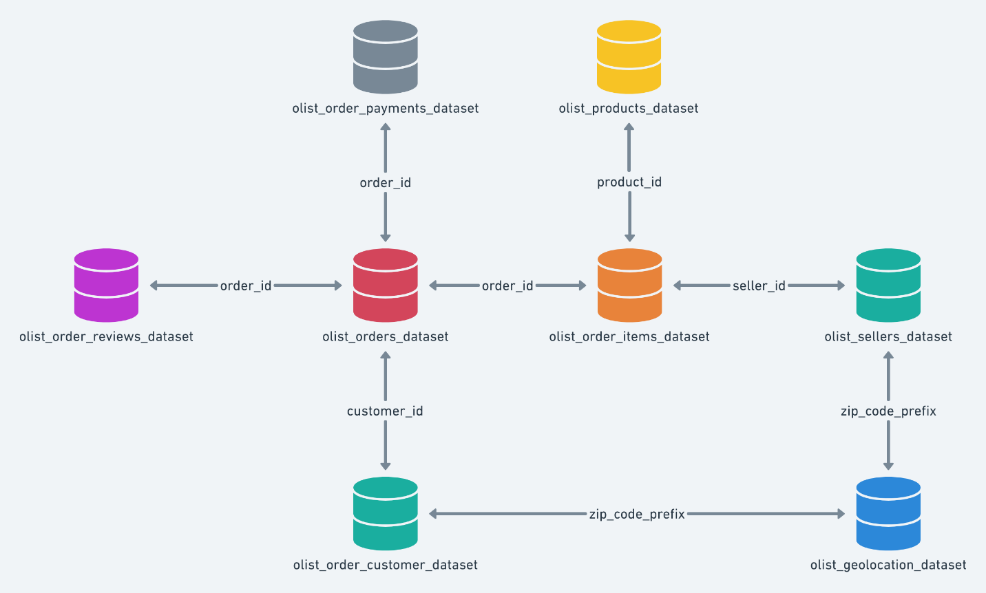

4. BUSINESS KPIs
Students are expected to define and analyze key performance indicators including:
- Total Orders
- Delivered Orders %
- Cancelled Orders %
- Average Delivery Time
- On-Time Delivery Rate
- Average Order Value
- Customer Retention Rate
- Average Review Score

5. APPROACH
Phase 1: Data Setup & Understanding
- Load datasets into SQL
- Understand schema and relationships

Phase 2: Data Cleaning & Preparation
- Handle missing values
- Convert date fields
- Validate consistency

Phase 3: Data Integration
- Perform joins across tables
- Build analytical dataset

Phase 4: Analysis
- Calculate KPIs
- Perform business analysis
- Identify trends and patterns

Phase 5: Reporting & Visualization
- Build dashboards
- Generate insights
- Provide recommendations

6. ADVANCED ANALYTICS (OPTIONAL)

Students may choose to perform advanced analytics for deeper insights.

Option 1: RFM Analysis (SQL / Excel / Python)
Objective:
Segment customers based on purchasing behavior:
- Recency → Last purchase
- Frequency → Number of orders
- Monetary → Total spend
Business Impact:
- Identify high-value customers
- Detect at-risk customers
- Improve targeted marketing strategies
Option 2: Customer or Seller Clustering
Objective:
Group customers or sellers based on behavior (orders, revenue, delivery performance)
Business Impact:
- Identify distinct customer segments
- Benchmark seller performance
- Enable strategic decision-making
Option 3: Trend / Predictive Analysis
Objective:
Analyze order trends or basic forecasting
Business Impact:
- Understand growth patterns
- Support planning and forecasting
Optional Tool Usage
Python can be used for:
- Data exploration
- Clustering
- Correlation analysis
- Trend analysis
Note: SQL and visualization remain primary. Python is optional.
7. ANALYTICAL TASKS
🔹 Task 1: Overall Order Operations Health Check
Question:
What is the total number of orders, delivered orders, cancelled orders, and average order value across the dataset?
Business Focus:
This task serves as the initial operational health check of the e-commerce platform.
You are observing whether order fulfillment is efficient or if cancellations indicate systemic issues.
A high cancellation rate may reflect logistics inefficiencies, seller-related issues, or customer dissatisfaction, which directly impacts business performance.
🔹 Task 2: Order Lifecycle Performance
Question:
What is the distribution of orders across different statuses (delivered, cancelled, shipped, etc.)?
Business Focus:
This task evaluates the efficiency of the order lifecycle.
You are identifying whether orders successfully progress through all stages or fail at specific points.
This helps detect operational bottlenecks and inefficiencies in order processing and fulfillment.
🔹 Task 3: Delivery Time Analysis
Question:
What is the average delivery time from order purchase to actual delivery?
Business Focus:
This task measures logistics performance and operational efficiency.
You are analyzing whether delivery timelines are consistent or significantly delayed.
Long delivery durations may indicate inefficiencies in logistics, seller processing time, or supply chain issues.
🔹 Task 4: Delivery Delay Analysis
Question:
How many orders are delivered after the estimated delivery date?
Business Focus:
This task identifies gaps between promised and actual delivery performance.
You are evaluating whether delivery commitments are being met consistently.
Frequent delays negatively impact customer trust and satisfaction, making this a critical operational metric.
🔹 Task 5: Seller Performance Benchmarking
Question:
For each seller, what are the total orders handled, average delivery time, and average customer review score?
Business Focus:
This task evaluates seller-level performance across multiple dimensions.
You are identifying top-performing sellers as well as those contributing to delays or poor customer experience.
This supports seller performance management and platform quality improvement.
🔹 Task 6: Customer Distribution & Demand Analysis
Question:
Which regions or cities generate the highest number of customers and orders?
Business Focus:
This task identifies geographic demand concentration.
You are analyzing where customer activity is highest to understand key markets.
This insight supports targeted marketing, regional expansion, and logistics planning.
🔹 Task 7: Product Category Performance
Question:
Which product categories generate the highest order volume and revenue?
Business Focus:
This task evaluates product-level contribution to overall business performance.
You are identifying high-demand and high-revenue categories.
This supports inventory planning, pricing strategies, and product focus.
🔹 Task 8: Payment Behavior Analysis
Question:
What is the distribution of payment methods and their contribution to total revenue?
Business Focus:
This task analyzes customer payment preferences and behavior.
You are identifying dominant payment methods and their impact on revenue.
This helps optimize payment systems and improve user experience.
🔹 Task 9: Customer Satisfaction Analysis
Question:
What is the distribution of customer review scores across all orders?
Business Focus:
This task evaluates overall customer satisfaction levels.
You are analyzing whether customers are generally satisfied or dissatisfied.
This helps assess service quality and identify areas requiring improvement.
🔹 Task 10: Delivery vs Review Relationship
Question:
How does delivery time impact customer review scores?
Business Focus:
This task identifies the relationship between operational performance and customer satisfaction.
You are analyzing whether delayed deliveries result in lower review scores.
This insight helps prioritize improvements in logistics and delivery processes.
🔹 Task 11: Order Value & Revenue Analysis
Question:
What is the average order value across different product categories?
Business Focus:
This task evaluates revenue contribution by category.
You are identifying high-value segments that contribute significantly to revenue.
This supports pricing strategies, product positioning, and revenue optimization.
🔹 Task 12: Time-Based Order Trends
Question:
How do order volumes vary over time (monthly or yearly)?
Business Focus:
This task identifies demand trends and seasonality patterns.
You are observing growth trends, fluctuations, and peak periods.
This supports forecasting, planning, and inventory management.
🔹 Task 13: Customer Retention Analysis
Question:
How many customers make repeat purchases?
Business Focus:
This task evaluates customer loyalty and retention behavior.
You are identifying repeat customers versus one-time buyers.
This insight supports customer engagement strategies and retention initiatives.
🔹 Task 14: High-Risk Order Identification
Question:
Which orders have long delivery times and low review scores?
Business Focus:
This task identifies worst-case customer experiences.
You are analyzing transactions that negatively impact customer satisfaction.
This supports root-cause analysis and corrective action to improve service quality.
🔹 Task 15: Executive Performance Summary
Question:
Create a consolidated summary including total orders, delivery performance, customer satisfaction, and key insights.
Business Focus:
This task provides a decision-ready executive overview.
You are summarizing key findings to answer:
“Where are inefficiencies occurring, and what actions should be taken to improve performance?”
This enables data-driven strategic decision-making.
🔹 8. DASHBOARD REQUIREMENTS
Students must create a dashboard using Power BI or Tableau.
Dashboard Must Include:
- KPI Cards
- Delivery performance
- Category performance
- Seller performance
- Customer insights
- Time trends
🔹 9. DELIVERABLES
Presentation Deck
- 10–15 slides
- Problem definition
- Methodology
- Analysis & findings
- Insights and recommendations
Data Files
- Raw dataset
- Cleaned dataset
- SQL scripts
Dashboard
- Power BI / Tableau file
- Must be executive-ready
10. VISUALIZATION GUIDELINES
- Maintain clarity and simplicity
- Focus on business KPIs
- Ensure storytelling through visuals
- Translate insights into actionable recommendations
11. EXPECTED LEARNING OUTCOMES
By completing this project, learners will be able to:
- Translate business problems into analytical frameworks
- Work with multi-table relational datasets
- Apply SQL and analytics techniques
- Build interactive dashboards
- Communicate insights effectively
- Make data-driven decisions
FINAL NOTE
This project is designed to simulate real-world business analytics challenges.
Focus on:
- Structured thinking
- Strong SQL logic
- Business interpretation
- Clear and impactful storytelling
Timeline:
The project must be completed and submitted within the Deadline.
References:
Project Orientation Video | Business Strategy Report- orientation video.mp4
How to Submit the project | how to submit project,ple,doubt-form.mp4
Capstone Explanation Guideline | Capstone Explanation Guideline
Project Live Evaluation | Project Live Evaluation
SAMPLE PPT | New Purplle

PROJECT DOUBT CLARIFICATION SESSION ( PROJECT AND CLASS DOUBTS)

About Session: The Project Doubt Clarification Session is a helpful resource for resolving questions and concerns about projects and class topics. It provides support in understanding project requirements, addressing code issues, and clarifying class concepts. The session aims to enhance comprehension and provide guidance to overcome challenges effectively.

For BMAI project/class topic doubt slot clarification session:

Session link : BMAI/BADM_Project Doubt Clarification Session Link

Timing: Tuesday, Thursday and Saturday (3:00PM to 4:00PM)

LIVE EVALUATION SESSION (CAPSTONE AND FINAL PROJECT)

About Session: The Live Evaluation Session for Capstone and Final Projects allows participants to showcase their projects and receive real-time feedback for improvement. It assesses project quality and provides an opportunity for discussion and evaluation.
Note: This form will Open only on Saturday (after 2 PM ) and Sunday on Every Week

Timing:

For BMAI and DE
Monday-Saturday (11:30AM to 1:00PM) and (05:30PM to 06:30PM)

Booking link : https://forms.gle/1m2Gsro41fLtZurRA

Evaluation Metrics : Project Live Evaluation

Approval Workflow

Created By: | Verified By: | Approved By:
Raghav Saluja | Geetha Pakala | Mohamed Ileeyas

